SALLY PHILLIPS
Education and Employment Review

My early years were spent seeking out and taking art classes when and where I could. I took classes at Sand Diego State, Museum of Man, the Museum of Contemporary Art in La Jolla, and in Spanish Village. My focus was on drawing the human figure and I took life drawing classes as often as possible.

After high school, I spent three years in the art department at UCLA. I worked on special projects in the classroom with artist Billy Al Bengston and furniture designer James McCabe. I also worked on the potting wheel and learned the details of human anatomy in the fine arts department.

Prior to my job with Queens Graphics, I worked for magazines and private firms, designing, illustrating, and learning all the technical aspects of layout and production. At Queen Graphics our primary function was within the record industry, designing jackets and promotional graphics. We produced camera ready art from our original concepts.

Since 1975 I have been involved with redesigning interior space and directing the project. I have been responsible for six such renovations from conception to completion. My basic concept has been to expand and utilize available interior space, designing for light and function.

As a partner in Market Street Design I have designed ads, brochures, labels, album cover, logos, point of purchase displays, magazine covers and concepts for illustration. My work demands a lot of photography.

In 1986 I began working in pastel. My subjects were from my photographs of Venice and the California coast. My work was in the Robert Berman Gallery in Venice.

In 1994 I moved to Kauai with my husband and two children. I began photographing the skies of Kauai. I turned the photographs into pastels. I successfully sold approximately 75 of my original pastels on Kauai. During that time I had shows in Los Angeles at Hal's restaurant in Venice and at the Rose Café.

Since 1994, as my children entered school, I began teaching art classes at their school. I began to see the great demand that there was for art in the classroom. In 1996, Gae Rusk and I decided to create funding for art classes in the school. We organized a hands-on art fair for children and adults. We provided art projects that included ceramics, paper mache masks, painting on fine are paper, on found objects and decorating donated items. The fair was a huge success and we hired art instructors and paid for art materials for the school out of the proceeds. The fair became a tradition at the school as is carried on even after Gae and I have gone on.

In 2000 I began teaching privately out of my home, adults and home-schooled students. I have seen wonderful results from my students and have enjoyed the teaching experience. I also taught classes at the Kilauea Community Center. I organized and taught a life drawing class for adults

I have since moved to San Diego and am presently teaching the San Diego Art Institute on Ray Street. I feel I have a range of experience with different materials and techniques and I enjoy teaching all ages.

Thank you for your consideration.

Sally Phillips
8219 Redlands Street, #4
Playa del Rey, CA 90293
(619) 255-3277
www.salllyphillipsart.com
sphillips.art@hotmail.com
Synopsis of Resume of:

SALLY PHILLIPS

San Diego, California 92107
(619) 255-3277

EMPLOYMENT:

10/71 – 05/72 BROCHURE, FORM DESIGNER
Industrial Indemnity Corporation
255 California Street
San Francisco, California

10/72 – 02/73 PRODUCTION, ILLUSTRATION
Hi-Torque Publications
1600 Ventura Boulevard
Encino, California

04/73 – 10/74 PRODUCTION, DESIGN
Queen Graphics
5852 Tuxedo Terrace
Hollywood, California

11/74 – 02/76 OWNER, DESIGNER
Parrot Imports
315 Washington Boulevard
Marina Del Rey, California

09/76 OWNER, DESIGNER
3000 Scenic Drive
Modesto, California

02/77 OWNER, DESIGNER
118 Hackberry Street
Modesto, California

02/78 OWNER, DESIGNER
Commercial Building
6730 3rd Street
Riverbank, California

04/78 OWNER, DESIGNER
Commercial Building
Bentley and E Streets
Waterford, California

06/76 – 06/78 FREELANCE, DESIGNER
Design Works West
3000 Scenic Drive
Modesto, California

08/80 – 10/85 OWNER, DESIGNER
Market Street Design
320 Market Street
Venice, California

1986 - PASTEL ARTIST
Robert Berman Gallery
Main Street
Venice, California

SALLY PHILLIPS

San Diego, California 92107
(619) 255-3277

Pastel Artist Gallery Shows 1986 - 2011:

1986 Robert Berman Gallery
Venice, California

1994 Kong Lung Company
Kilauea, Hawaii

1997 Kinipopo Gallery
Wailua, Hawaii

1st Place in Juried Show
Kauai Society of Artists
Winter Show

1998 Hale Mana Gallery
Poipu, Hawaii

1999 Hal’s Restaurant
Venice, California

Private Commission
Mural for Ching Young Shopping Center
Hanalei, Hawaii

2002 - 2005 Princeville Hotel
Princeville, Hawaii

2008 – 2010 The Art Institute
San Diego, California

2009 – 2011 SASU Fine Art
North Park, California

Pastel Artist Gallery Sales 1986 - 2011:

Robert Berman Gallery Los Angeles, CA 8

Kinipopo Gallery Wailua, HI 5

Kong Lung Company Kilauea, HI 11

Hale Mana Gallery Poipu, HI 4

Teaching Experience
1994 – 2005 Children's Art Classes
Kilauea School
Kilauea, Hawaii

1994 – 2005 Adult Life Drawing Classes
Children's Art Classes
Kilauea Neighborhood Center
Kilauea, Hawaii

2002 – 2006 Private Classes with adults and home schooled children
Hawaii and San Diego

2006 – 2010 Instructor for Pastel and Life Drawing Classes
The Art Institute
San Diego, California

ART CLASSES

MATERIALS: Drawing Board
Pastel Paper
Set of soft pastels

PASTEL CLASS DESCRIPTION:

Pastels have a depth and richness to them that is unique to this medium. We begin with the fun of blending colors before moving on to defining shapes in a still life. We concentrate on the colors of each object and where they are in relation to each other. Before any detail is added, the artwork is filled with life and drama simply by applying color. As the shadows and lines bring the artwork into focus, each artist is encouraged to find their own rhythm and style. They will learn techniques for working in pastels that will make their subjects come to life as their skills progress. At least one class will be taught outdoors so that we can work from natural light.

LIFE DRAWING CLASS
Learning to draw the human figure is an exciting and dynamic experience. We begin with circles. Large fluid circles and lines that later will be used to describe the action and expression of the model. We also spend some time in becoming familiar with the
muscle and bone structure of the body. The model will start with 30 second poses and will end with 1/2 hour to give the student time to explore hatching as a shading technique. These techniques combined with encouraging the individuality of the student have
made it possible for students to gain an enormous amount of confidence in their work.

Student Work

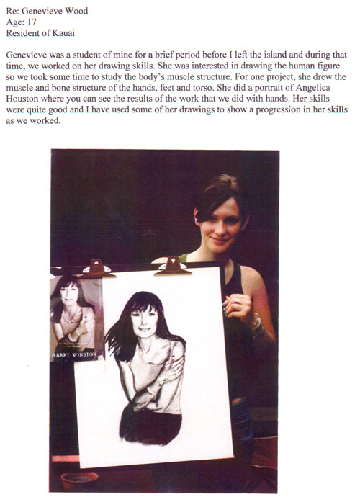

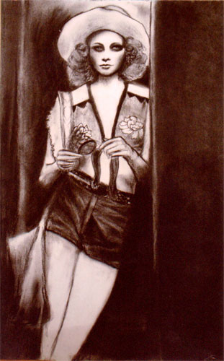
Brynne Tagawa
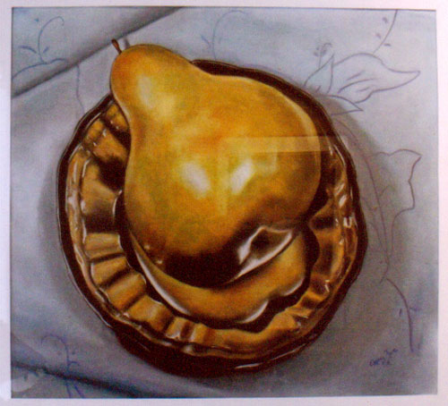
Amy Meharg
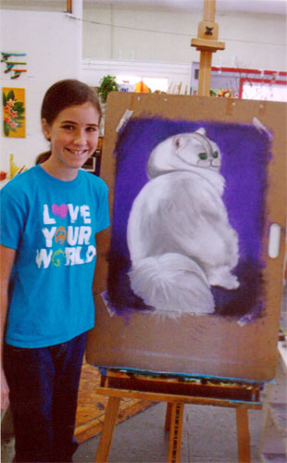
Bethany
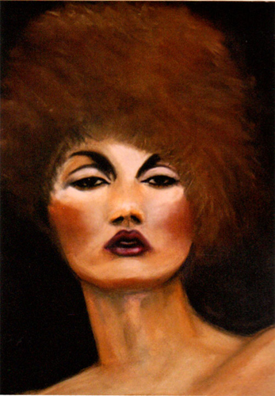
Brynne Tagawa

